JAS Blog Photo
---------------------------------------------------------------------------------------------------------

THE JACKASS OF THE WEEK
AWARD
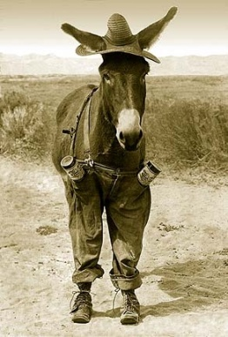
Chosen by readers

